# 



# 8408 N. IH 35

**Austin, TX 78753**

**Phone: 800-325-7427**

**Fax: 512-834-0758  
info@txpropane.com**

May 13, 2021

Stephanie Pollack, Acting Administrator

Federal Highway Administration

U.S. Department of Transportation

1200 New Jersey Avenue S.E.

Washington, DC 20590

Re: Docket No. FHWA-2020-0001; NATIONAL STANDARDS FOR TRAFFIC CONTROL DEVICES; THE MANUAL ON UNIFORM TRAFFIC CONTROL DEVICES FOR STREETS AND HIGHWAYS; REVISION

Dear Ms. Pollack:

The Texas Propane Gas Association represents propane retailers across the state that fuel propane school buses and other vehicle fleet powered by propane autogas. We hope you will review one **pending** decision your agency made during the previous administration to change the FHWA’s Manual on Uniform Traffic Control Devices to severely limit alternative fueling station roadway signage eligibility. It is our view that alternative fueling stations should have parity with petroleum stations when it comes to signage.

As you know, low public awareness about the availability of domestically produced alternative transportation fuels is one of greatest barriers to faster adoption. Highway signage is one clear step the government can easily take to promote the increasing availability of alternative transportation fuels which will lead to greater adoption of cleaner burning transportation fuels and all the associated benefits for the country—environmental security, energy security, and economic security.

We agree strongly with your previous statements that our country needs to ‘adopt innovative and collaborative approaches’ to ‘bend the curve on transportation greenhouse gas emissions, which continue to be the largest and fastest growing source of climate-altering pollution.’[1] There are currently 34,857 non-gasoline fueling stations open to the public.[2] In simple terms, those stations should have signage parity with petroleum fueling stations for the reasons outlined in this letter.

Our views are consistent with the purpose stated in the law when Congress established the Alternative Fuels Corridor program through Section 1413 of the FAST Act.[3] According to the text of the law, Congress created the corridor program “to improve the mobility of passenger and commercial vehicles that employ electric, hydrogen fuel cell, propane, and natural gas fueling technologies.” In this sense, we understand the term ‘mobility’ to be referring to the need to expand motorist ‘access’ to the fuels in order to be able to move freely and to enhance transportation options for motorists.

FHWA published goals of the alternative fuel corridor program in the federal register in 2016 and they include: to ‘promote the build out of a national network,’ to ‘develop national signage and branding to help catalyze applicant and public interest,’ to ‘promote and advance alternative fuel corridor designations,’ and because ‘alternative fuel corridors with support for lower-emitting vehicles can assist in the effort towards ‘achieving reductions in [greenhouse gas] emissions…from transportation sources.’[4]

We are including below a summary of our recommendations as well as a summary of changes proposed by your agency staff. We hope your office will conduct a serious review of this pending policy decision prior to the May 14, 2021 deadline and revise the MUTCD to create signage parity for alternative fuel stations.

**RECOMMENDED CHANGES TO THE FHWA PROPOSAL:**

* Change the word GAS to FUEL and define GAS and FUEL in the manual to include alternative fuels. These terms should be defined to include at least the fuels Congress included in the FHWA Alternative Fuels Corridor Program (electric, hydrogen fuel cell, propane, natural gas) under 23 U.S.C. 151. Precedent for this recommendation already exists, some states that have changed GAS to FUEL in their own version of the manual.
* States should have the flexibility to use either General Service or Specific Service signs for Alternative fuel stations. If a state desires to incorporate alternative fueling stations into their existing logo programs, they should not be prohibited from doing so by FHWA. States that wish to incorporate alternative fueling station signage into their program using General Service signs should also have this option.
* Businesses with logo panels in categories other than GAS should be permitted to include a supplemental message indicating the availability of an alternative fuel at their location. For example, a coffee shop should not be prohibited from including a supplemental message on their Specific Service sign panel indicating the availability of electric vehicle charging at their location.
* States should be permitted to use the Alternative Fuels Corridor identification sign as a way of notifying road users that they are on an existing corridor without a requirement to also utilize General Service and/or Specific Service signs.

**ADVERSE UNFAVORABLE CHANGES FHWA HAS PROPOSED TO THE MUTCD IN WHICH WE ARE OPPOSED:**

* Alternative Fuel stations will be prohibited from using Specific Service signs unless they are also a gasoline station. *The only transportation fueling station permitted to display their logo on a highway sign will be a gasoline station.*
* Alternative fuels can only be listed on specific service signs as a supplemental message along the bottom of a gasoline station logo sign panel.  *For example, a gasoline station could indicate on their GAS sign logo they have propane Autogas or electric vehicle charging available but a standalone, non-gasoline vehicle fueling station has no way to include their logo on a sign.*
* Categories of businesses other than gasoline stations with logo signs (FOOD, LODGING, ATTRACTION) will be prohibited from including a supplemental message indicating they offer an alternative fuel*. For example, a coffee shop will be prohibited from adding a supplemental message on the FOOD sign indicating they have EV charging available at their location. Likewise, a hotel would be unable to indicate on the bottom of their sign they offer EV charging.*
* Signing for alternative fueling stations will only be permitted using General Service signs. *This is against the wishes of many states that would prefer to sign for alternative fueling stations using Specific Service signs.*
* It is understandable that the FHWA proposal designates that Alternative Fuels Corridor sign(s) shall only be installed on highways officially designated as Alternative Fuel Corridors. *States should not, however, be prohibited from using the Alternative Fuels Corridor sign for the sole purpose of raising corridor awareness in a manner consistent with what FHWA published in the federal register in 2016 under the administration of President Barack Obama.[5]*

We appreciate your service to our country and stand ready to assist you to achieve our mutual goals.

Sincerely,

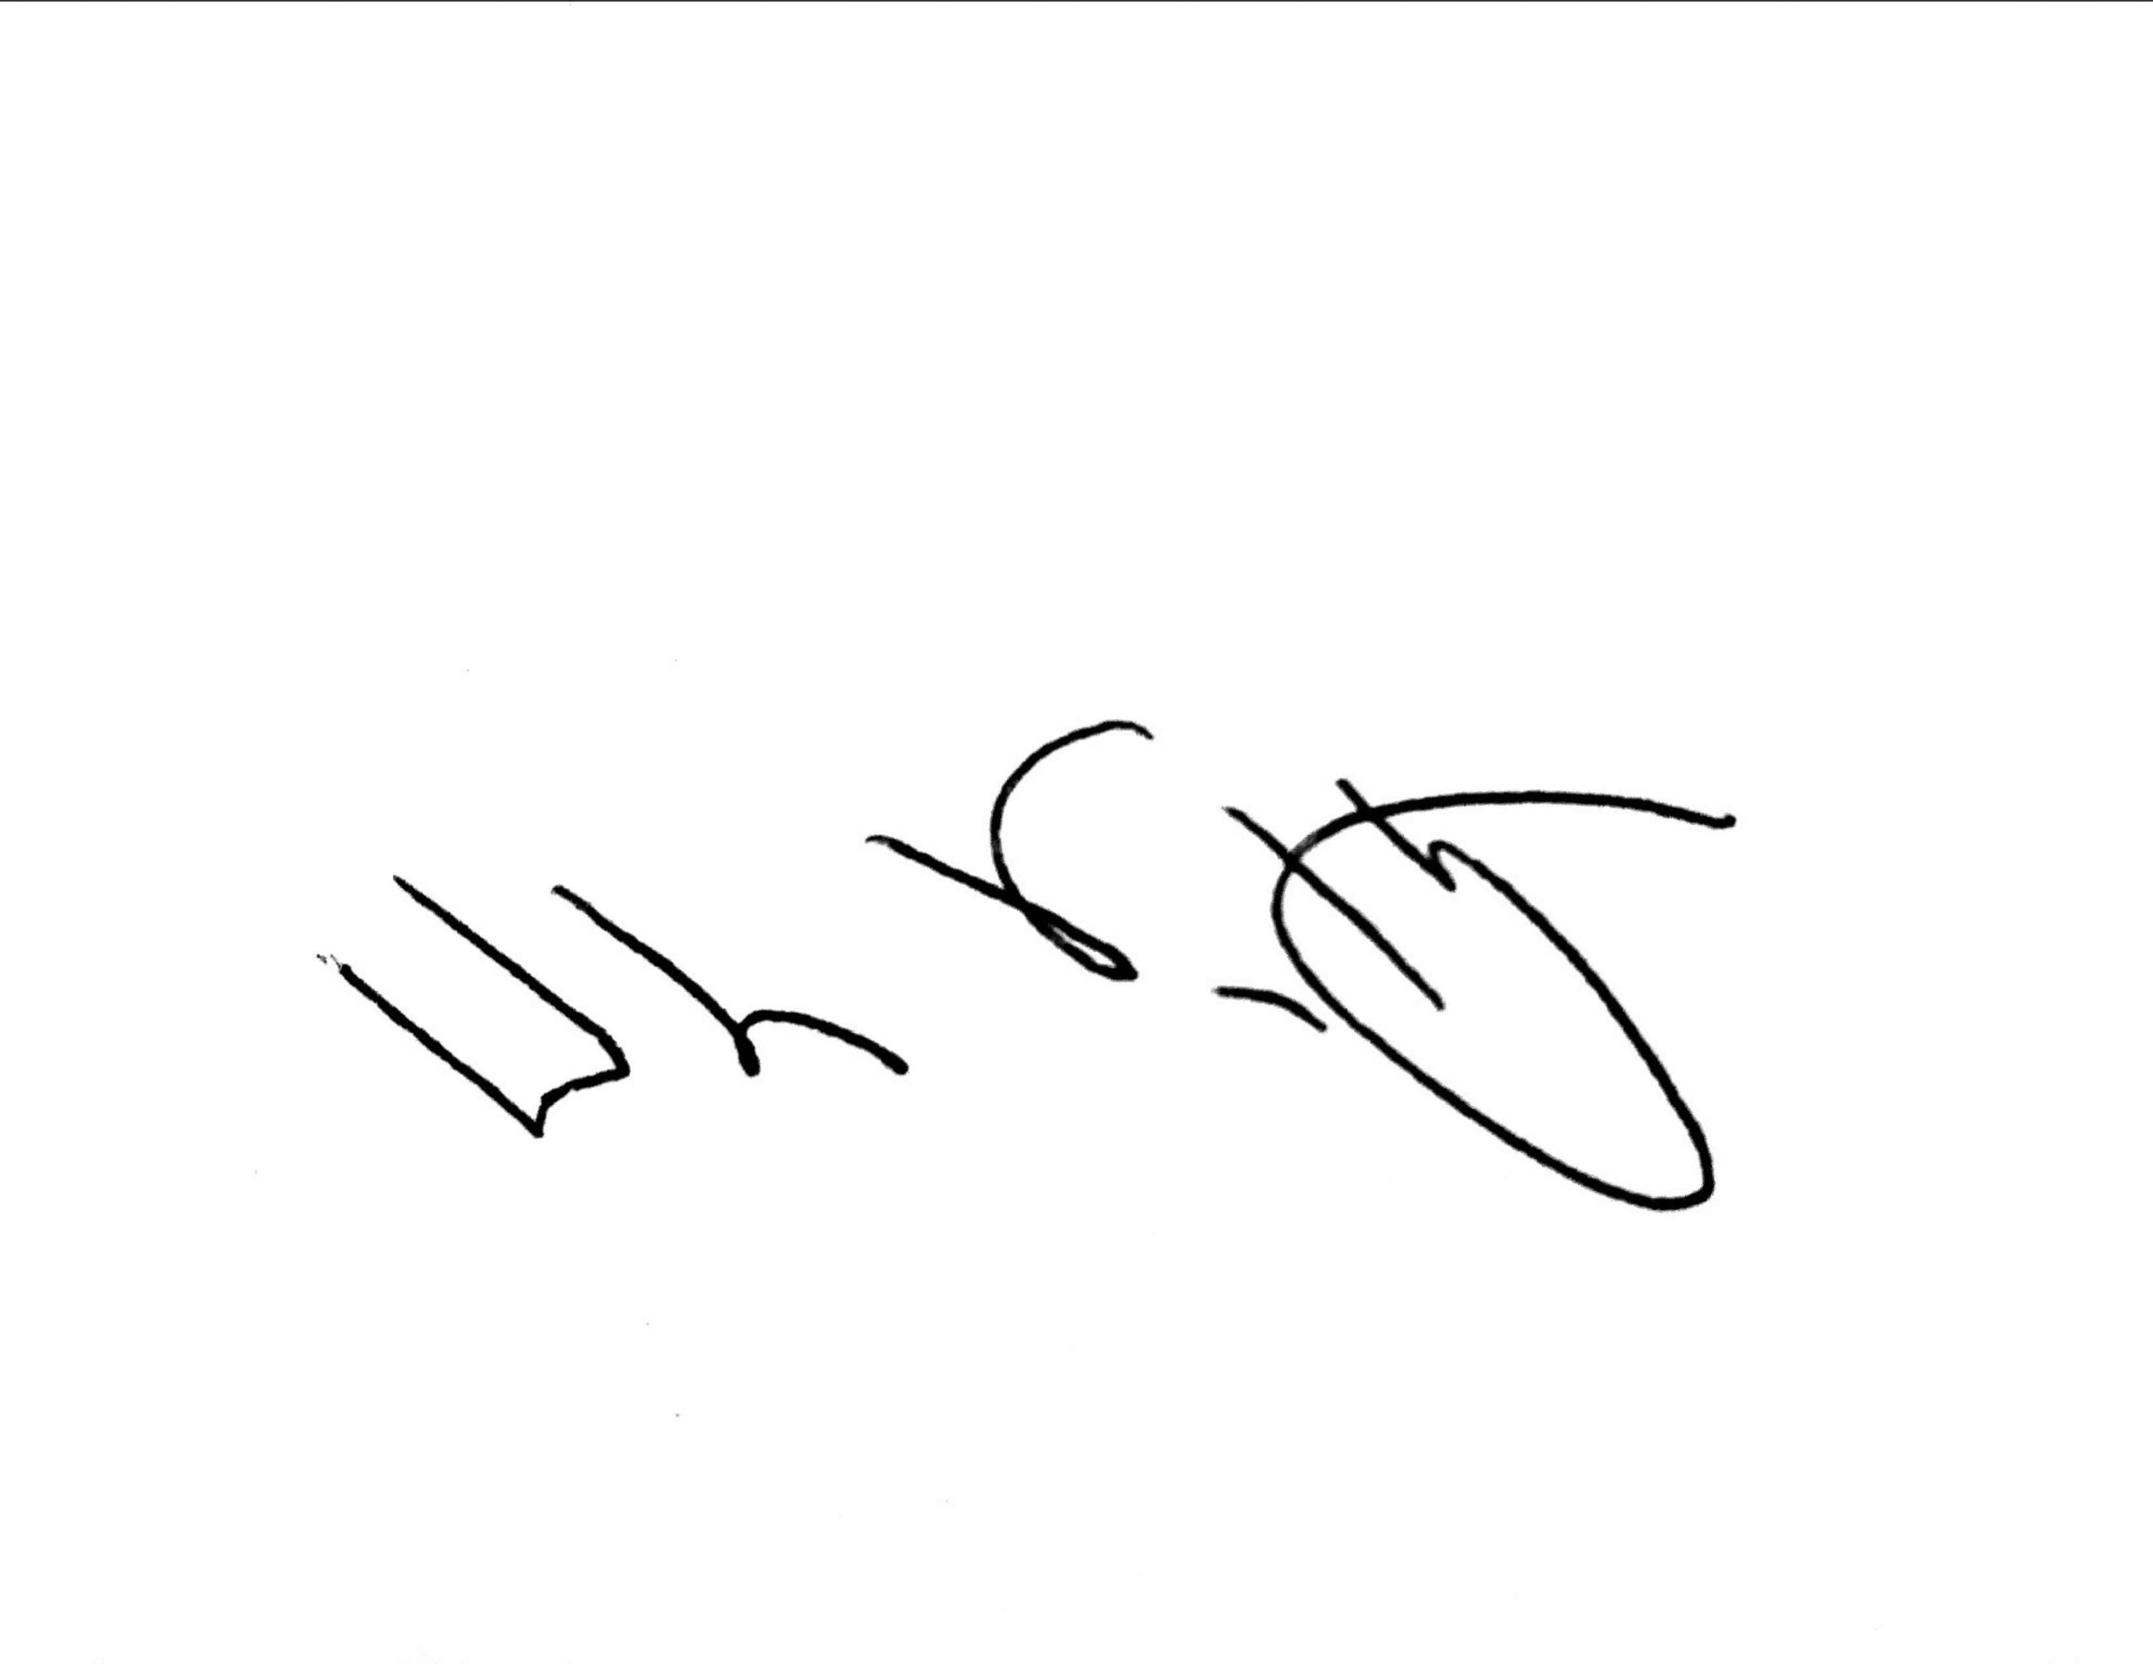

William Van Hoy

1. <https://www.transportationandclimate.org/statements-state-leaders-launch-tci-p>
2. [*https://afdc.energy.gov/stations/#/find/nearest?country=US*](https://afdc.energy.gov/stations/#/find/nearest?country=US)
3. <https://www.congress.gov/bill/114th-congress/house-bill/22/text/enr>
4. <https://www.govinfo.gov/content/pkg/FR-2016-07-22/pdf/FR-2016-07-22.pdf>
5. <https://www.govinfo.gov/content/pkg/FR-2016-07-22/pdf/FR-2016-07-22.pdf>